Magnet Transport Calibration

BASIC ALGORITHM

When the tong is holding the magnet in the holder, it only has half freedom: rising in Z direction. In all other directions, it will hit a wall. So we can use force sensor to find the neutral place. For example, we can scan U to find minimum Z torque.

Here is on scan of TZ vs. U:
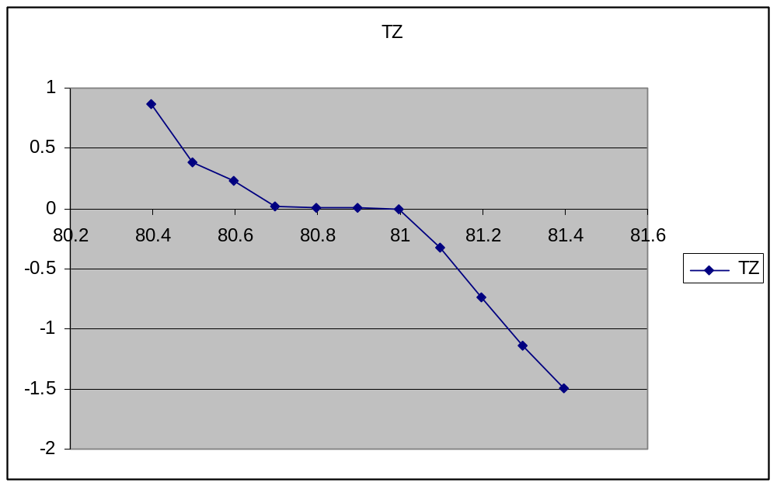

The basic algorithm is to use a small threshold, find the U where TZ cross +threshold and the U where TZ cross –threshold, then take the middle of them as our desired U position.

TZ in the flat part in the middle is not zero. Above method is better than taking the TZ crossing zero as the desired U.

This method works in X, Y, and U. For Z, because it only has one wall, the bottom, we use touch the bottom then reduce the FZ to a small number to consider that is our desired Z position.

DIVIDE AND CONQUER

The magnet is along the Y axis of robot and Y axis of force sensor when it is in the holder. So, we can reduce each force separately: change X to reduce X force or Y torque, change Y to reduce Y force and X torque, and change U to reduce Z torque.

Because the tong holding magnet on the far end from the force sensor, X torque is much more sensitive than Y force. So we selected following as our force indicator:
X Torque scan Y to reduce it
Y Torque scan X to reduce it
Z Torque scan U to reduce it
Z Force scan Z to find the bottom

To pick which force to reduce at a time, we defined some weight for each force.
- X Torque has the least weight. The magnet holder has about 1mm freedom in Y direction. We do not want to scratch the magnet when there is big force in other directions.
- Z Torque has the largest weight. It uses bigger force to generate Z Torque.
- Next is Z force. This force is between the bottom and the magnet. If it is there, it will affect all others. Make it difficult to move in all other directions.

OVERALL

We pick one force to reduce at one time and repeat this procedure for maximum times until all forces are within a minimum value and Z is bottomed.

FORCE SENSOR NOISE REDUCTION

In XY torque, there is about 0.3 lb-in noise when we move in XY plane. Even when it is still and force free, sometimes, we can get some spider reading like 5 or 6 in torques. One time we even saw 206 in the force reading when that should be zero.

We take following method to reduce the noise:
- 100 samples for each reading with interval of 0.001 second. This is to ensure each sample is a new data (hardware speed 7K/second)
- Find the samples distribution by divide them into 10 bins. Then cuts 25 samples from each side and only take the middle 50 samples to do average.

Above method only works in reading force. To use force as trigger to stop the robot, the threshold must be much bigger than the noise. So we take 1.5 as typical threshold for force trigger threshold. In trigger setup, we increase this threshold by another 20%. It works in most of the cases. As a back up, if the move with trigger failed, we will scan the robot with small steps and read the force by our readforce method to check whether we reach the threshold.

